Sprint 1 - Endurance Design Document

November 9, 2021

# Executive Summary

## Project Overview

* The goal of this project is to create a plan and write code to allow the Sphero robot to navigate a path through the Sprint 1 Endurance course in HH208.
* The intended audience is the CS104 class and Professor Eckert.

## Purpose and Scope of this Specification

**In scope**

* Meeting the requirements of the Sprint 1 Endurance course

**Out of Scope**

* Meeting requirements of the Sprint 2 Accuracy course
* Meeting requirements of the Sprint 3 Agility course

# Product/Service Description

## Product Context

* This project is not related to the others.
* Each of the sprint projects are self-contained.

## User Characteristics

* Student/Teacher
* Programmer

## Assumptions

* HH208 will be available for testing the code with the robot.
* We will use the Sphero robot will be used to complete the project
* Sphero Edu will be used to design the code

## Constraints

Describe any items that will constrain the design options, including

* Must use block code on Sphero Edu
* Must use the path in HH208
* HH208 will not always be available

## Dependencies

List dependencies that affect the requirements. Examples:

* HH208 will need to be available for testing code with the robot.
* Sphero Edu will need to be available to write the code for the robot

# Requirements

|  |  |  |  |  |  |
| --- | --- | --- | --- | --- | --- |
| **Req#** | **Requirement** | **Comments** | **Priority** | **Date Rvwd** | **SME Reviewed / Approved** |
| ENDUR_01 | Robot must successfully travel around the periphery of HH208. |  | 1 | 11/5 |  |
| ENDUR_02 | Robot must start with a green light and say “Ready set go.” |  | 1 | 11/5 |  |
| ENDUR_03 | Robot must stop with a red light and say “I’m done and I need water.” |  | 1 | 11/5 |  |
| ENDUR_04 | Robot should not collide with any objects as it goes around the room. |  | 1 | 11/5 |  |
| ENDUR_05 | Robot must finish on the square where it started. |  | 1 | 11/5 |  |
|  |  |  |  |  |  |
|  |  |  |  |  |  |
|  |  |  |  |  |  |
| ENDUR_XX |  |  |  |  |  |

## Security

### Protection

Specify the factors that will protect the system from malicious or accidental access, modification, disclosure, destruction, or misuse. For example:

* Access to the block code is protected by a login to a Sphero Edu account.

### Authorization and Authentication

* You must enter a correct email and password to access the Sphero Edu account where the block code is located.

## Portability

If portability is a requirement, specify attributes of the system that relate to the ease of porting the system to other host machines and/or operating systems. For example,

* The code and robot are portable and can be moved
* The track for the requirements can not be moved

# Requirements Confirmation/Stakeholder sign-off

Include documentation of the approval or confirmation of the requirements here. For example:

|  |  |  |
| --- | --- | --- |
| **Meeting Date** | **Attendees (name and role)** | **Comments** |
| MM/DD/YY | Patrick Frohn, Programmer | confirmed |
| MM/DD/YY | Madison Kapuscinski, Plan Designer | confirmed |

# System Design

This section will provide all details concerning the technical design, staffing, coding, and testing the system

## Algorithm

Develop and describe here the algorithm that will be used to provide the required performance of your software

1. Start
2. Main LED Green
3. Speak “Ready set go” and continue
4. Roll 90 degrees
5. Roll 180 degrees
6. Roll 270 degrees
7. Roll 0 degrees
8. Fade LED from Green to Red
9. Speak “I’m done and I need water.” and continue
10. Stop

## System Flow

Develop a flowchart (and show here) that accurately depicts how your software application will act to fulfill the algorithm

## 

## Software

Describe software languages/platforms/api’s used to develop and deploy this application

* Sphero Edu Block Code

## 

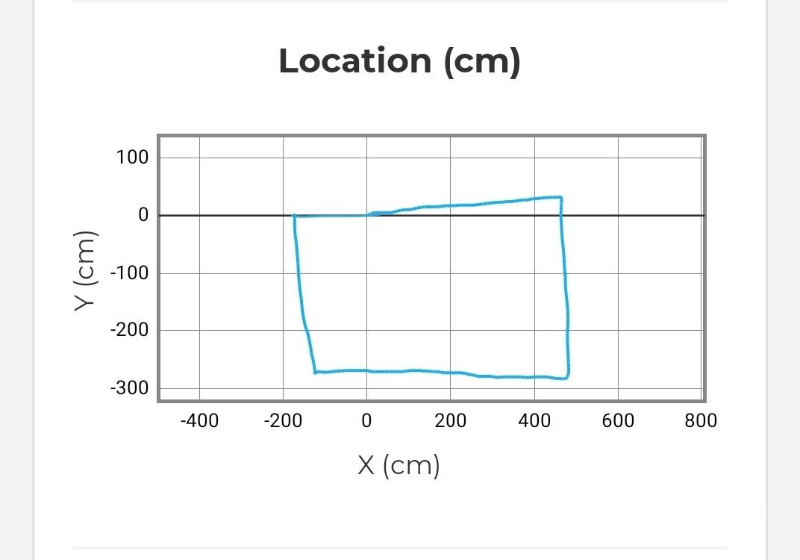

## Hardware

Describe hardware platforms that were used to develop, test and demonstrate this application

* Sphero Mini

## Test Plan

Include a test plan showing all unit tests performed for this application, Include test rational, test date, staff member, pass/fail status

|  |  |  |  |  |  |
| --- | --- | --- | --- | --- | --- |
| **Reason for Test Case** | **Test Date** | **Expected Output** | **Observed Output** | **Staff Name** | **Pass/Fail** |
| To make sure the code is working correctly | 11/5 | Robt will start on green, speak, and then move | The robot started green spoke, and then moved | Patrick F.  Madison K.  Brandon V. | Pass |
| To test if the robot will follow the path. | 11/5 | The robot will roll forward to follow the path | The robot rolled backwards off the track | Patrick F.  Madison K.  Brandon V. | Fail |
| To see if the robot will roll forward. | 11/5 | The robot will roll forward onto the path | The robot rolled forward onto the path but drifted off eventually | Patrick F.  Madison K.  Brandon V. | Pass |
| To correct the drifting off the path. | 11/5 | The robot will stay on the path after it begins | The robot stayed on the path but fell short of getting to the first turn. | Patrick F.  Madison K.  Brandon V. | Pass |
| Adjusted time of rolling on the first straight | 11/5 | Robot will get to the end of the first straight and complete the turn | The robot did not make it to the first turn. Needed slightly more time | Patrick F.  Madison K.  Brandon V. | Fail |
| Adjusted time of rolling on the first straight | 11/5 | The robot will get to the end of the first straight and start the first turn | The robot completed the first straight and began the first turn but did not complete it. | Patrick F.  Madison K.  Brandon V. | Pass |
| Increasing time of rolling on the first turn | 11/5 | The robot will reach the end of the first turn and begin the second. | The robot got closer to the second turn but did not make it all the way to the end.Needs to increase roll time further | Patrick F.  Madison K.  Brandon V. | Fail |
| Increasing time of rolling on the first turn more | 11/5 | The robot will reach the end of the first turn and begin the second | The robot completed the distance of the first turn and began the second. | Patrick F.  Madison K.  Brandon V. | Pass |
| To test if the robot will complete the whole course | 11/5 | The robot will complete the course and stop on the square it started | The robot did complete all turns on the course and stopped where it began. | Patrick F.  Madison K.  Brandon V. | Pass |
| Adding LED lights and speaking to code | 11/5 | The robot will begin with a green light and speak and end with a red light and speak. | The robot spoke and had a green light to begin and ended the course with a red light and spoke. | Patrick F.  Madison K.  Brandon V. | Pass |
|  |  |  |  |  |  |

## Task List/Gantt Chart

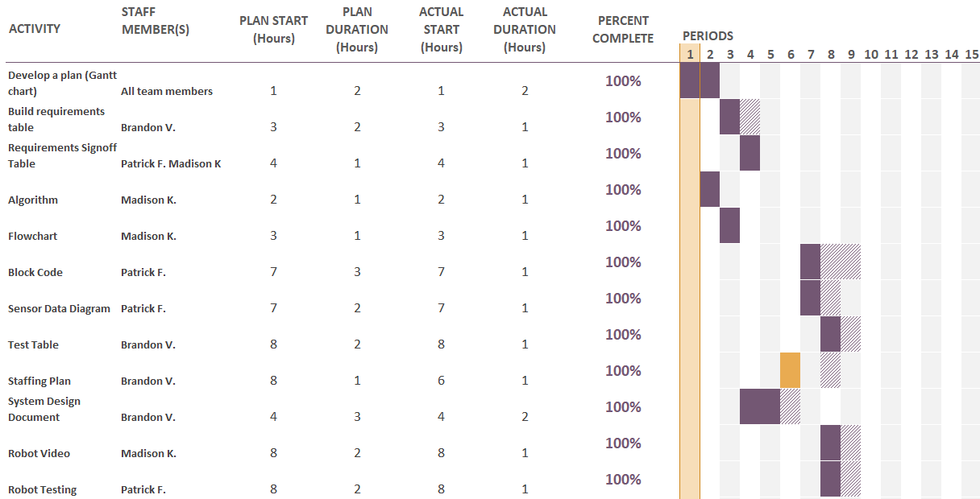

## Staffing Plan

|  |  |  |  |
| --- | --- | --- | --- |
| Name | Role | Responsibility | Reports To |
| Patrick Frohn | Programmer | * Block Code, * Sensor Data, * Robot Testing, * Requirements Sign Off Table * Gantt Chart | Madison K.  Brandon V. |
| Madison Kapuscinski | Plan Designer | * Algorithm * Flowchart * Robot Video * Requirements Sign off Table * Gantt Chart | Patrick F.  Brandon V. |
| Brandon Valentine | Information Recorder | * Requirements Table * Test Table * Staffing Plan * System Design Document * Gantt Chart | Patrick F.  Madison K. |